Last Week In Review - May 24-30
Alex Shvartsman

TGP TURIN
Just over 100 teams traveled to Northern Italy for TGP Turin. Although there were many familiar faces from USA, France, and a few other countries, many of the GP regulars were also missing. Turin took place during the same weekend as German, UK, and Swedish nationals, causing many of the top players to skip this one.
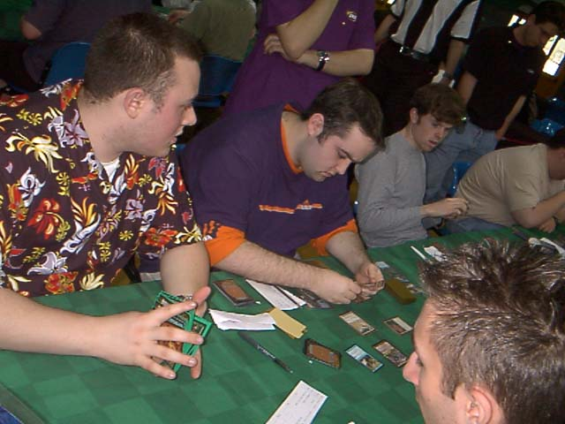
One of the coolest things about attending a team tournament, is coming up with a memorable team name. Often, the names are humorous - inside jokes or obvious puns. Some of the best team names from the past include "The Tightans" playing on the word "tight" being a popular slang term among pro players, and "Being Zvi Mowshowitz". At this tournament, Steve OMS, Dave OMS and David Williams amused everyone by calling their team "RevisedFourthFifth.com," poking fun at "AlphaBetaUnlimited.com" team.
My own team's name was "Gotta Catch Kai" as it included Mike Pustilnik and Zvi Mowshowitz - two of the top 5 in the current Player of the Year race.
After six rounds of Sealed Deck and three rounds of draft, it was the Dutch teams that totally dominated the tournament. Bram Snepvangers's and Kamiel Cornelissen's teams both made the Top 4. AlphaBetaUnlimited made finals for the second TGP in a row, but it was an American team of Dan Clegg, Brock Parker and Peter Szigeti that took the top prize.
Outcome of GP Turin allowed Kamiel Cornelissen to overcome Pustilnik by a single pro point, becoming second in the Player of the Year race. Ryan Fuller sped ahead of Zvi Mowshowitz to become a solid fourth. Although it would be hard for any of these players to catch Kai Budde, they are also battling for the top 5 positions in the POTY race, which would earn them automatic invites to the next Magic Invitational, to be held in South Africa.
As the season is approaching conclusion at Worlds this August, there are only two Team Grand Prix left for players to pick up extra points at. These Grand Prix are Taipei, Taiwan and Columbus, USA. Taipei may likely become the most-attended by European and American players of the four Taiwanese Grand Prix, as many teams are considering the trip. Columbus will be the only North American TGP and is likely to gather a very impressive collection of Pro teams.

MAGIC TRIVIA
Last week's question:
What tournament-playable uncommon card was misprinted with an artwork of a blue rare in Spanish Fourth Edition?
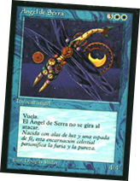
Serra Angel. Dubbed "Serra Elemental" by collectors, this uncommon card was printed with an artwork from Time Elemental. One of the most sought-after misprints, "Serra Elemental" sells for $30 or more currently.
New question:
What pro player managed to come in 1st, 9th and 10th in 3 US National Championships in a row?
Please do not e-mail me your answers. The correct answer will be posted in next week's column.

PLAY OF THE WEEK
This play comes from the head judge of GP Turin, Gis Hoogendijk.
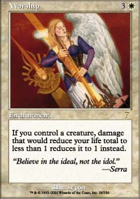
"I was testing Standard with a friend. He was playing some deck with Worship and counters, I was playing Counterrebel. He was drawing lots of cards and had Worship in play and a couple of creatures. I didn't see a way to win except for decking him because I did not have a Disenchant left... he was at 1 though. My hand was full of counters and we both had loads of land. So my next turn I drew a card and just couldn't stop grinning...hopefully my 5 counters would be enough :-) I attacked all out he didn't block. "Damage on the stack?" I asked him, he looked at me slightly confused and said sure. I played Rout as an instant, he looked at me again (eyes popping out) and we entered the counter battle which I luckily won."

BAD PLAY OF THE WEEK
My teammate Mike Pustilnik was playing the third game of the deciding match against Trey Van Cleave at GP Turin. Pustilnik had Plague Spitter, Kavu Climber, and a few 2/2 and 3/2 creatures in play. Van Cleave had several 2/4's.
Pustilnik chose to cast Breath of Darigaaz with kicker to clear the board. He then cast Explosive Growth (no kicker) on his Kavu Climber! Problem is, Climber already had a point of damage on it from Plague Spitter and would get four more damage from Breath and one more from Spitter going to the graveyard, for the total of six damage. Apparently, Pustilnik was not the only one oblivious to this. Van Cleave used his Confound to counter the Explosive Growth!
As always, please send good/bad plays, cool trivia questions, and other news to ashv@concentric.net

